Exploratory Differential Gene-Expression and Pathway Analysis of CD34+ Cells in Chronic-Phase CML
Anam Abid | Independent Computational Biology Project | September 2026

1. Introduction
Chronic myeloid leukemia (CML) is a hematopoietic stem cell malignancy driven by the reciprocal translocation t(9;22)(q34;q11), commonly known as the Philadelphia chromosome. This translocation creates a BCR::ABL1 fusion gene, whose encoded constitutively active tyrosine kinase drives abnormal signaling, altered hematopoietic regulation, and leukemic proliferation (BCR-ABL1 is also widely used for the same fusion and is used interchangeably with BCR::ABL1 throughout this report).
This project builds directly on an earlier independent analysis in which I performed a multiple sequence alignment and phylogenetic analysis of four BCR-ABL1 fusion transcript variants, identifying a conserved ABL1-derived region and clustering patterns consistent with known BCR breakpoint relationships. That project examined the disease at the sequence level. The present project extends that sequence-level analysis to transcriptome-level investigation. Rather than asking how BCR-ABL1-associated fusion variants differ in sequence structure, it examines which genes and biological pathways show altered expression in primary CD34+ cells from patients with chronic-phase CML compared with healthy donors.
The specific aim of this project was to identify which genes and biological pathways show altered expression in primary CD34+ cells from patients with chronic-phase CML compared with healthy donors, and to place the resulting gene list in biological context using pathway enrichment analysis.

2. Dataset
The analysis used a public dataset from the NCBI Gene Expression Omnibus (GEO), accession GSE5550 (https://www.ncbi.nlm.nih.gov/geo/query/acc.cgi?acc=GSE5550): “Molecular signature of CD34+ hematopoietic stem and progenitor cells in chronic phase CML” (Diaz-Blanco et al., Leukemia, 2007; PMID: 17252012). The dataset compares gene expression profiles of immunomagnetically enriched bone marrow CD34+ cells from 9 untreated chronic-phase CML patients against 8 healthy bone marrow donors, profiled on Affymetrix HG-Focus microarrays covering 8,746 genes.
The dataset was selected, after an initial candidate dataset was found to have only one sample per condition (insufficient for statistical testing), because it provides biological replication suitable for exploratory analysis, with 9 CML and 8 normal samples, and because it directly examines primary CD34+ cells from patients with chronic-phase CML. Its disease context also creates a biologically coherent connection to my earlier BCR-ABL1 sequence-analysis project.

3. Methods

3.1 Differential Expression Analysis
All analysis in this project started from the publicly available, already-normalized GSE5550 series matrix (not raw CEL files); no additional background correction or renormalization was performed; the only downstream data-handling step was mapping platform probe annotations to gene symbols for visualization and enrichment (Section 3.2–3.3), which did not alter the underlying expression matrix. Differential gene expression between CML and normal samples was assessed using GEO2R, the NCBI GEO web-based analysis tool, which applies a limma-based linear-model framework to GEO expression data. Genes were ranked by adjusted p-value (Benjamini-Hochberg false discovery rate correction). Genes were classified as significantly upregulated or downregulated if they met a combined threshold of adjusted p-value < 0.05 and |log2 fold change| > 1. Where multiple platform probes mapped to the same official gene symbol, the project repository documents the exact rule used to select or summarize probes before downstream visualization and enrichment. The specific GEO2R settings used (sample group definitions, log-transformation option, and platform annotation category) are also recorded in the repository, since GEO2R results can vary with these settings.

3.2 Visualization
A volcano plot was generated in Python (matplotlib) to visualize the relationship between statistical significance (-log10 adjusted p-value) and effect size (log2 fold change) across all 8,746 tested genes. A heatmap of the 25 most significant platform probes (by adjusted p-value), represented by their mapped gene annotations, was generated by extracting per-sample normalized expression values for these probes (retrieved via the GEOparse Python library from the GSE5550 series matrix), converting each probe's expression across the 17 samples to a z-score, and rendering the result as a color-coded matrix (matplotlib imshow, coolwarm colormap).

3.3 Pathway Enrichment Analysis
The top 25 most significant probes (by adjusted p-value) were converted to 28 individual official gene symbols, after splitting compound probe annotations that mapped to more than one gene (e.g., a single probe annotated as WTH3DI///RAB6C///RAB6A was split into its three constituent gene symbols), and submitted as a single, direction-mixed query set to Enrichr (Xie et al., 2021), a web-based gene-set enrichment analysis tool, accessed in September 2026; the exact library names and access date used are recorded alongside the full enrichment output in the project repository (Section 8). All 28 submitted gene symbols were successfully recognized by Enrichr. The analysis used Enrichr's default background configuration rather than a custom background restricted to the 8,746 genes assayed on the Affymetrix HG-Focus array; because Enrichr's default background may not exactly represent the array's gene universe, the pathway results below should be treated as exploratory rather than confirmatory. Enrichr reported enrichment statistics for the KEGG 2026, Reactome, and MSigDB Hallmark libraries based on Fisher's exact/hypergeometric testing, with Benjamini-Hochberg-adjusted values. Upregulated and downregulated genes were not analyzed as separate query sets in this version of the analysis; this is noted as a limitation in Section 6.

4. Results

4.1 Differential Expression Overview
Of the 8,746 genes tested, 3,174 were statistically significant at adjusted p-value < 0.05. Applying the additional |log2FC| > 1 effect-size threshold narrowed this to 28 upregulated and 26 downregulated genes (54 genes total), shown in the volcano plot below. These 3,174 and 54-gene counts should not be numerically compared with the 918 significant genes reported by Diaz-Blanco et al. (2007) for this same dataset (using a q-value < 0.1% and fold-change > 1.3 SAM-based criterion), because the two analyses used different statistical procedures, multiple-testing criteria, and effect-size definitions, and preprocessing/annotation choices may also contribute. The difference in gene counts reflects differing statistical pipelines rather than a discrepancy in the underlying data.
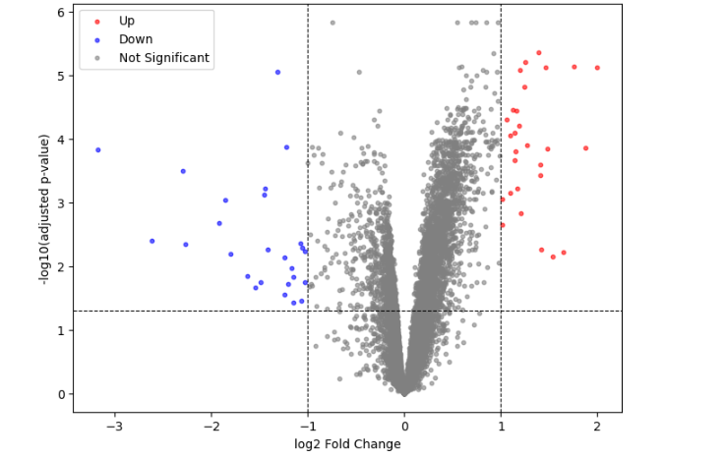
Figure 1. Volcano plot of differential gene expression, CML vs. normal CD34+ cells (GSE5550). Red points: significantly upregulated genes (adjusted p < 0.05, log2FC > 1). Blue points: significantly downregulated genes (adjusted p < 0.05, log2FC < -1). Dashed lines indicate significance and fold-change thresholds.

4.2 Key Genes of Biological Interest
ABL1 and BCR — the two genes that form the canonical fusion associated with CML — appeared among the statistically significant genes by adjusted p-value (ABL1 logFC = +0.69; BCR logFC = -0.67), although neither exceeded the pre-specified |log2FC| > 1 effect-size threshold and so neither is part of the 54-gene effect-size-filtered set described in Section 4.1. Because standard Affymetrix expression probes measure gene-level ABL1 or BCR transcript signal rather than uniquely quantifying the BCR-ABL1 fusion junction, this result should not be interpreted as a direct measurement of fusion-transcript abundance. Several established BCR-ABL1 signaling components were also identified among the significant genes; these are summarized in Table 1. The genes in Table 1 are reported using their standard, unambiguous gene symbols; this table is distinct from the compound probe-annotation expansion (25 probes to 28 symbols) used only for the pathway-enrichment input described in Section 3.3. Among the genes listed in Table 1, FLT3 is the only one that meets both the adjusted p-value and |log2FC| > 1 criteria.
Gene | logFC | Adj. p-value | Passes |log2FC|>1? | Interpretation
ABL1 | +0.69 | 1.46 × 10⁻⁶ | No | BCR-ABL1 fusion partner; significant by adjusted p-value but below the effect-size cutoff. The array probe measures ABL1 gene-level signal, not the fusion junction specifically.
BCR | -0.67 | 7.99 × 10⁻⁵ | No | Fusion partner of ABL1; same caveat as above — significant but below effect-size threshold, and not a direct fusion-transcript measurement.
STAT5A / STAT5B | +0.51 / +0.51 | 1.17 × 10⁻⁴ / 9.27 × 10⁻⁵ | No | Downstream effectors of BCR-ABL1 signaling; significant but below effect-size threshold.
CRKL | +0.51 | 1.09 × 10⁻⁴ | No | BCR-ABL1 substrate/adaptor protein; significant but below effect-size threshold.
LYN | +0.64 | 3.23 × 10⁻⁵ | No | Src-family kinase linked to BCR-ABL1-driven proliferation and TKI resistance; significant but below effect-size threshold.
FLT3 | -1.23 | 1.36 × 10⁻⁴ | Yes | Hematopoietic growth-factor receptor; among the genes in this table, FLT3 is the only one that meets both the adjusted p-value and |log2FC| > 1 criteria and is part of the 54-gene filtered set.
GATA1 / GATA2 / TAL1 | +0.96 / +0.87 / +0.94 | 1.04 × 10⁻⁴ / 1.11 × 10⁻⁴ / 1.06 × 10⁻⁴ | No | Hematopoietic transcription factors involved in lineage regulation; significant but below effect-size threshold.
Table 1. Selected genes of biological interest among the statistically significant results (adjusted p < 0.05). Yellow: significant by adjusted p-value only, below the |log2FC| > 1 effect-size threshold used to define the 54-gene set. Green: passes both thresholds.

4.3 Heatmap of Top Differentially Expressed Genes
The heatmap below shows a visually distinct expression pattern between the analyzed CML and normal samples across the 25 platform probes ranked most significant by adjusted p-value, represented by their mapped gene annotations. Because these probes were selected using the same dataset in which their expression is visualized, the apparent separation may be optimistic and does not constitute independent classification evidence; it should be treated as exploratory rather than as independent evidence of a diagnostic or disease-specific signature, and it does not rule out contributions from batch effects, sample-source differences, cell-composition differences, or other technical variation (see Section 6).
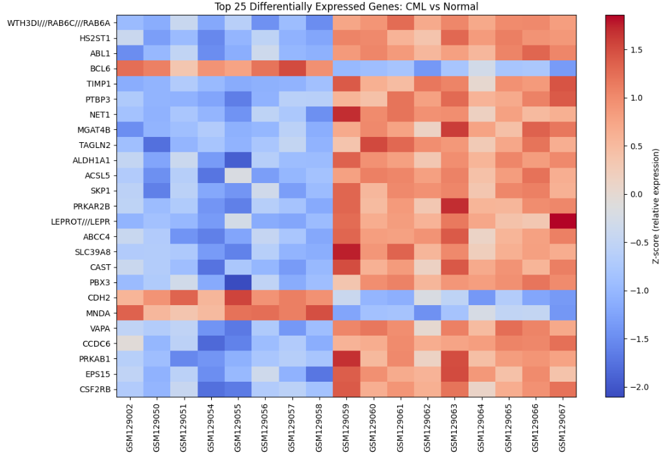
Figure 2. Row-wise z-score heatmap of the 25 platform probes ranked most significant by adjusted p-value across 17 samples: 8 normal donors and 9 untreated chronic-phase CML patients. Gene annotations are shown according to the platform mapping.

4.4 Pathway Enrichment
Pathway enrichment analysis was performed on the 28-gene symbol set derived from the 25 most significant probes (Section 3.3). These symbols were run against the KEGG 2026, Reactome, and MSigDB Hallmark libraries in Enrichr; Table 2 presents the top KEGG 2026 results only, since these were the strongest and most interpretable hits. Reactome and MSigDB Hallmark results are available in the full enrichment output in the project's GitHub repository (Section 8) rather than reproduced here. The distinction between adjusted-significant and nominally significant KEGG results is preserved below and should not be collapsed.
Pathway | P-value | Adjusted P-value | Odds Ratio | Combined Score
Adipocytokine Signaling Pathway | 0.000126 | 0.0082 | 35.65 | 320.02
Circadian Rhythm | 0.00103 | 0.0325 | 47.93 | 329.63
Ferroptosis | 0.00150 | 0.0325 | 39.32 | 255.68
Pathways in Cancer | 0.00583 | 0.0947 | 6.22 | 32.01
JAK-STAT Signaling Pathway | 0.0227 | 0.147 | 9.23 | 34.94
Table 2. Top KEGG 2026 pathway results from Enrichr analysis of the 28-gene symbol set derived from the 25 most significant probes. Green shading: adjusted p-value < 0.05 (statistically robust). Yellow shading: nominal p-value significant but adjusted p-value did not reach the 0.05 threshold (nominally enriched only). Combined score is a ranking metric provided by Enrichr and is not itself a significance measure.
The most statistically robust result in this exploratory pathway analysis was enrichment of the Adipocytokine Signaling Pathway (adjusted p = 0.0082), which included LEPR and LEPROT among the submitted genes. Given the small, direction-mixed input list and non-custom background, this result should be viewed as hypothesis-generating rather than as evidence of pathway activation in CML. Pathways in Cancer and JAK-STAT Signaling Pathway were both nominally enriched (raw p < 0.05) but did not remain significant after multiple-testing correction (adjusted p = 0.0947 and 0.147, respectively), despite JAK-STAT signaling being biologically plausible given BCR-ABL1's well-established constitutive activation of this pathway. This may reflect the small input gene list, overlap between pathway gene sets, or limited statistical power; the present analysis cannot distinguish among these explanations, and these two pathways should not be described as significant.

5. Discussion
The observation that ABL1 and BCR appeared among the adjusted-p-value-significant genes, despite not being pre-specified as selection targets, provides biological concordance with the disease context. The presence of CRKL, LYN, and STAT5A/STAT5B among the adjusted-p-value-significant results is biologically compatible with reported BCR::ABL1-associated signaling (e.g., Diaz-Blanco et al., 2007, who reported activation of the classical MAPK pathway and PI3K/AKT pathway, and downregulation of the pro-apoptotic gene IRF8, in the same dataset), although the present analysis does not establish their mechanistic involvement or disease-specific activation. Because this result was derived from, and then compared against, prior literature on the same dataset and disease mechanism, it should be read as concordance rather than as independent validation.
The detection of GATA1, GATA2, and TAL1 — hematopoietic transcription factors involved in lineage regulation — among the upregulated genes is consistent with the original study's finding of an altered differentiation-associated gene signature in CML CD34+ cells, reflecting a shift in the composition of the stem/progenitor cell compartment rather than a uniform block in differentiation.
Taken together with my earlier sequence-level phylogenetic analysis of BCR-ABL1 fusion variants, this project illustrates two complementary computational approaches to the same disease mechanism: one characterizing the structure of the causal fusion event itself, and the other characterizing transcriptional patterns associated with the same disease context in primary patient cells.

6. Limitations
- Platform age: the dataset was generated on an Affymetrix HG-Focus array (published 2007), an older and lower-density platform than current RNA-sequencing methods; some genes of interest may not be represented, and absolute expression values are not directly comparable to modern RNA-seq datasets.
- Sample size: the 9 CML and 8 normal samples provide biological replication suitable for an exploratory limma-based analysis, but the modest cohort size limits precision, generalizability, and independent validation; the pathway enrichment step additionally operated on a small, direction-mixed set of 28 gene symbols derived from 25 probes, which limits statistical power, though it cannot be said with certainty that low power alone explains why pathways such as JAK-STAT signaling did not survive multiple-testing correction (see Section 4.4).
- No independent validation: differential expression findings were not confirmed with an orthogonal method (e.g., qPCR) or an independent replication cohort; findings should be interpreted as hypothesis-generating.
- Bulk, not single-cell, resolution: the CD34+ population is heterogeneous, and bulk expression differences may partly reflect shifts in cell-subtype composition (as noted by the original study authors) rather than uniform changes within a single cell type.
- Association, not mechanism: this analysis identifies correlative gene-expression differences; it does not establish causal relationships between any individual gene and disease progression.
- Feature-selection circularity: the heatmap genes were selected using the same samples used to visualize group separation; therefore, the apparent separation may be optimistic and does not represent independent predictive validation. A principal component analysis (PCA) on the full sample set, using genes not selected from this same comparison, would be a stronger next step than has been performed here.
- Probe-level and annotation limitations: because the platform is an older Affymetrix array, probe-to-gene mapping and transcript specificity may limit interpretation, particularly for genes with multiple isoforms or fusion-related biology — this is especially relevant to the ABL1/BCR interpretation in Section 4.2, since these probes cannot distinguish fusion-transcript signal from normal-allele signal.
- Annotation expansion and probe ambiguity: the 25 selected probes yielded 28 submitted gene symbols because some platform annotations contained multiple symbols separated by “///” (e.g., WTH3DI///RAB6C///RAB6A). These symbols may not represent independent measurements, and compound annotations may affect the enrichment results; the corresponding probe may not uniquely distinguish among the listed genes. WTH3DI specifically is a legacy alias for the official gene RAB6D (NCBI Gene ID 150786), so this probe corresponds to three RAB6-family paralogs (RAB6A, RAB6C, RAB6D) rather than three independently distinct, unrelated genes; Enrichr’s recognition of the symbol WTH3DI reflects this alias mapping rather than an ambiguous or unofficial annotation. Pathway results involving such symbols, and the pathway analysis as a whole, should therefore be interpreted as exploratory at the level of the mapped gene-symbol set rather than as definitive evidence for all listed genes.
- Direction-mixed enrichment input: the 28-symbol enrichment set combined upregulated and downregulated annotations into a single query. This can obscure whether an enriched pathway reflects coordinated activation, coordinated repression, or a mixture of both; pathway enrichment results in this report should therefore not be interpreted as evidence of pathway activation or inhibition, only as evidence of over-representation among the differentially expressed genes.

7. Conclusion
This project performed an independent exploratory analysis of normalized expression data from the public GSE5550 dataset, comparing CD34+ hematopoietic stem and progenitor cells from untreated chronic-phase CML patients with healthy bone-marrow donors. Using a limma-based GEO2R workflow, Python visualization, and exploratory pathway enrichment, the analysis identified expression differences and pathway-level signals concordant with reported CML-associated biology. The findings are hypothesis-generating rather than clinically validated, particularly because the dataset is modest in size, was generated on an older microarray platform, used a small, direction-mixed mapped-gene input set and a non-custom enrichment background, and lacks independent replication. Together with my earlier BCR-ABL1 sequence-analysis project, this work demonstrates a self-directed progression from sequence-level analysis toward transcriptome-level investigation of leukemia biology.

8. Data and Code Availability
Dataset: NCBI GEO accession GSE5550 (https://www.ncbi.nlm.nih.gov/geo/query/acc.cgi?acc=GSE5550). Analysis code (Python/Google Colab notebook), the full differential expression results table (with adjusted p-values for every tested gene), sample/group metadata, and the full Enrichr pathway enrichment output (including Reactome and MSigDB Hallmark results, exact library names, and access date) are available on GitHub: github.com/anam-abid003/cml-gene-expression-analysis. A README accompanying the repository documents the dataset, methods (including how duplicate probes mapping to the same gene were handled), limitations, and steps to reproduce the analysis, and confirms that GEO2R (statistical testing) and GEOparse (visualization) were run on the same sample groups and gene identifiers.

9. References
Diaz-Blanco E, Bruns I, Neumann F, Fischer JC, Graef T, Rosskopf M, Brors B, Pfister D, von Haeseler A, Kobbe G, Haas R, Gattermann N, Kronenwett R. Molecular signature of CD34(+) hematopoietic stem and progenitor cells of patients with CML in chronic phase. Leukemia. 2007 Mar;21(3):494-504. PMID: 17252012.
Barrett T, Wilhite SE, Ledoux P, et al. NCBI GEO: archive for functional genomics data sets—update. Nucleic Acids Res. 2013;41(D1):D991-D995.
Clough E, Barrett T. The Gene Expression Omnibus Database. Methods Mol Biol. 2016;1418:93-110.
Xie Z, Bailey A, Kuleshov MV, et al. Gene Set Knowledge Discovery with Enrichr. Curr Protoc. 2021;1(3):e90.
Ritchie ME, Phipson B, Wu D, et al. limma powers differential expression analyses for RNA-sequencing and microarray studies. Nucleic Acids Res. 2015;43(7):e47.

